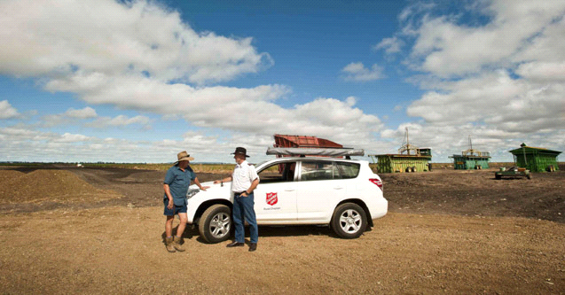

The Salvation Army is working together with St Vincent de Paul Society to deliver the Drought Community Support Initiative (DCSI) for eligible drought affected households.

If you're a farmer, farm worker or farm supplier/contractor who is struggling financially because of the drought, you may be entitled to receive a one-off payment of up to $3,000 funded by the Australian Government’s Drought Community Support Initiative Round 2 (DCSI).

To be eligible you'll need to be over 18, an Australian citizen or permanent resident, and live/work in a specified Local Government Area (LGA). Payments can cover numerous expenses such as groceries, vehicle maintenance, energy & utility bills, health & medical expenses, for example.

Please note that assistance might be provided by either The Salvation Army or Vinnies, depending on your Local Government Area (LGA). The list of eligible LGAs and which organisation you should approach can be found at www.salvationarmy.org/drought.

Upon completion of your application for financial assistance you may be required to submit a valid form of I.D.

To make an application for assistance please phone the Drought Community Support team on 1300 551 030. You may need to leave your name and phone number, and an Assessor will phone you back. Due to the high demand we are working as quickly as possible to respond to all applications.

