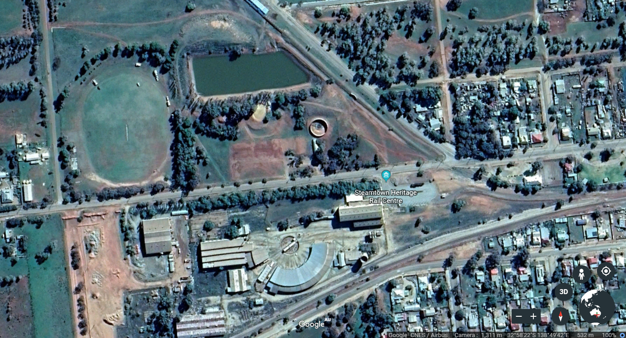

RV PARK

Jamestown



Peterborough Main St



STEAMTOWN

& VIC

Off-Leash Dog Park