OODLA WIRRA Access Rd: Rowe Street, off Barrier Highway, south west of Oodla Wirra
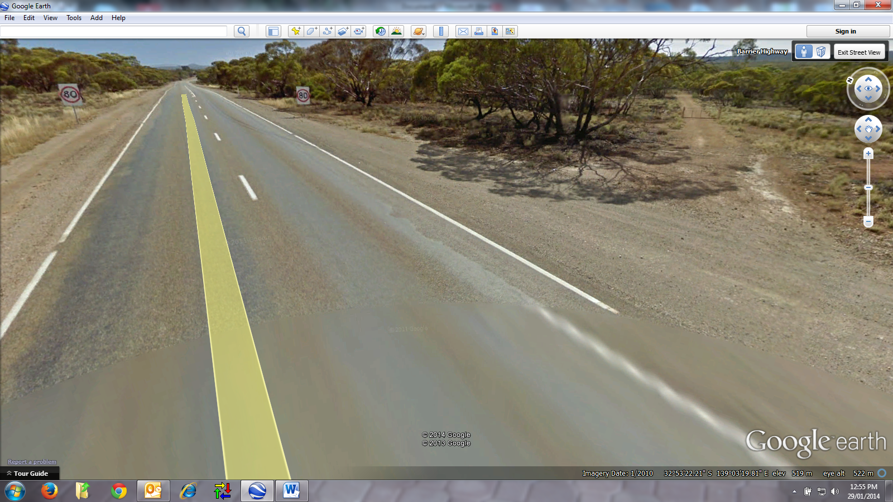

OODLA WIRRA CEMETERY
